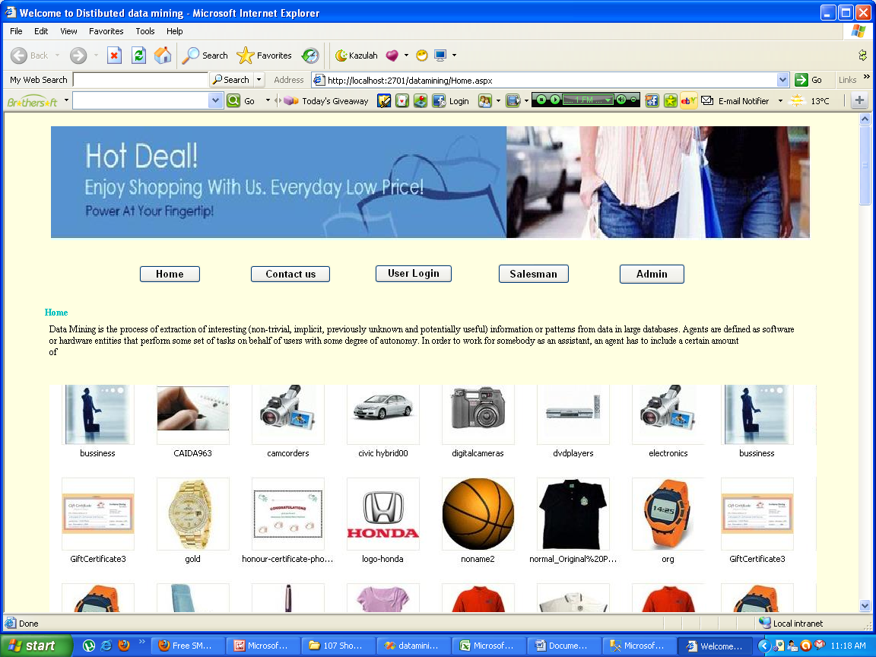
Pagename: Home page
Fields: child page
Process: navigates to child pages

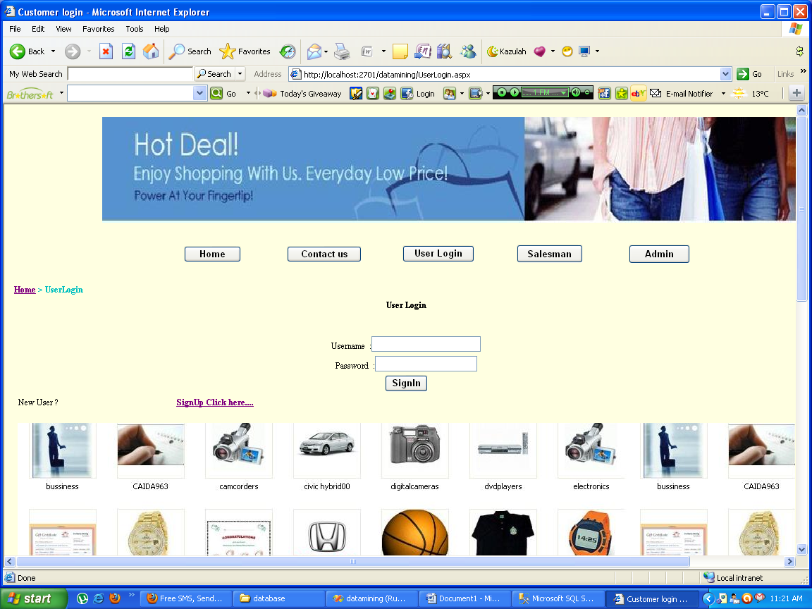
Pagename: user login
Fields: username,password,signin,signup
Process: navigates to user profile
Table: tbl_login
Remarks: enter credentials
Error: no

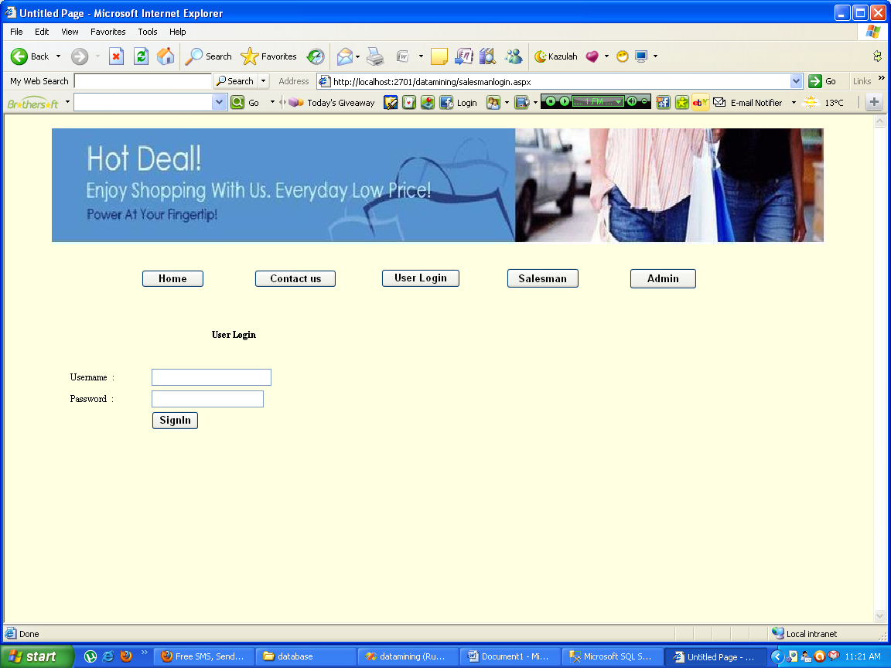
Pagename: user login
Fields: username,password,signin,signup
Process: navigates to user profile
Table: tbl_login
Remarks: enter credentials
Error: no

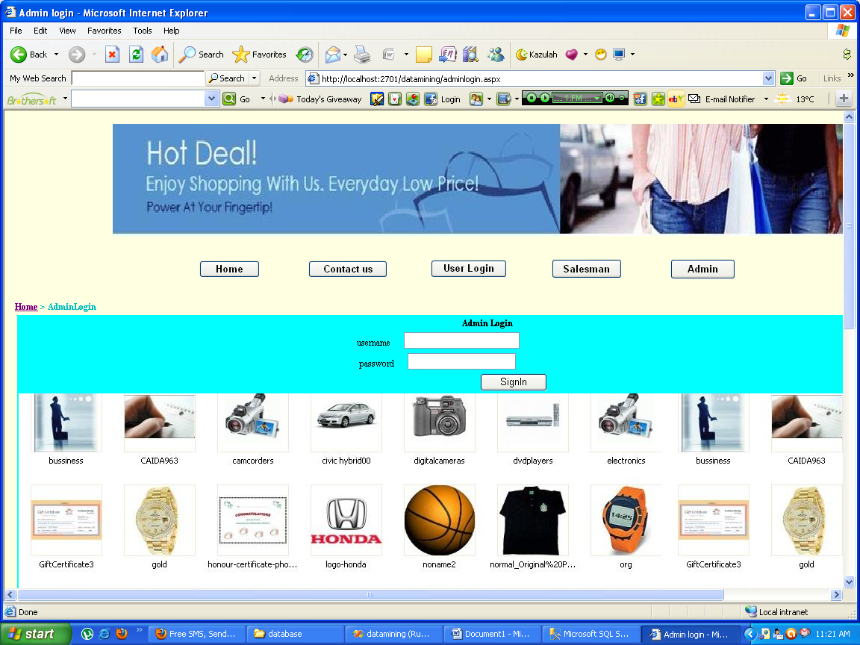
Pagename: user login
Fields: username,password,signin
Process: navigates to admin profile
Table: no
Remarks: enter credentials
Error: no

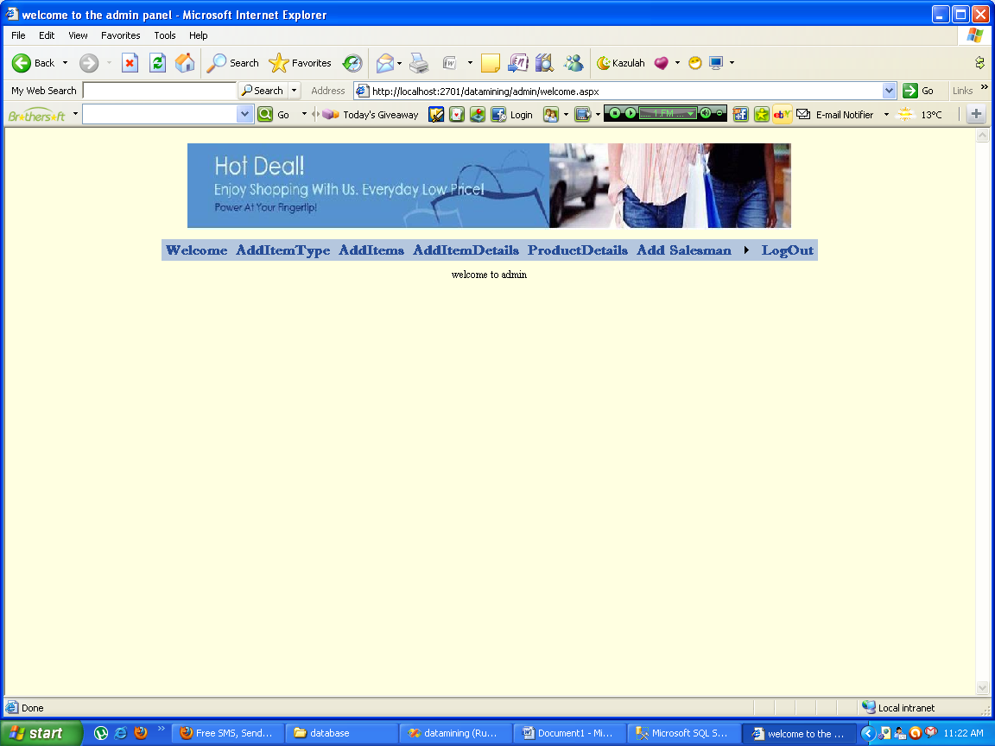
Pagename: admin home page
Fields: child pages

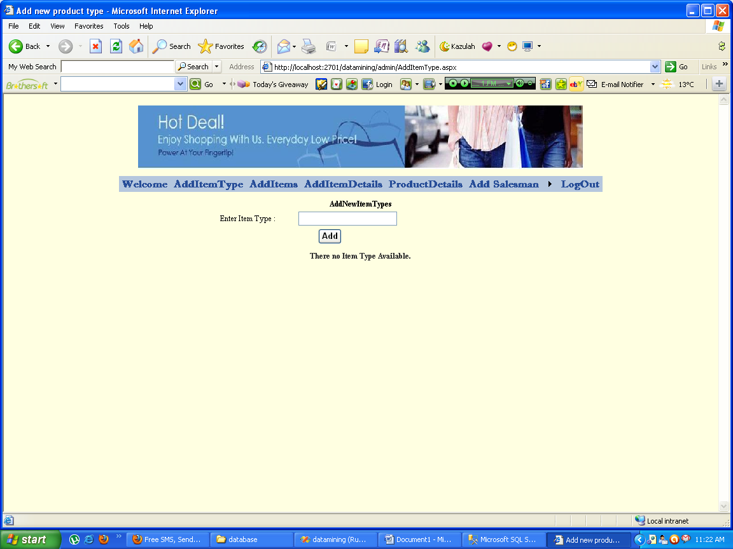
Pagename: add new item types
Fields: item type,add
Process: can add new item type
Table: grid view
Remarks: enter name
Error: no

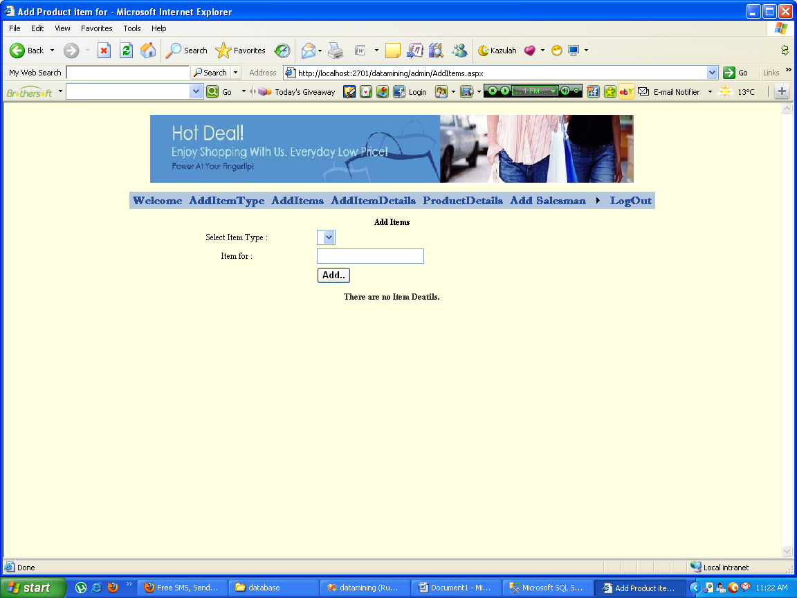
Pagename: add item
Fields: select item,item for,add
Process: can add item for
Table: grid view
Remarks: add
Error: no

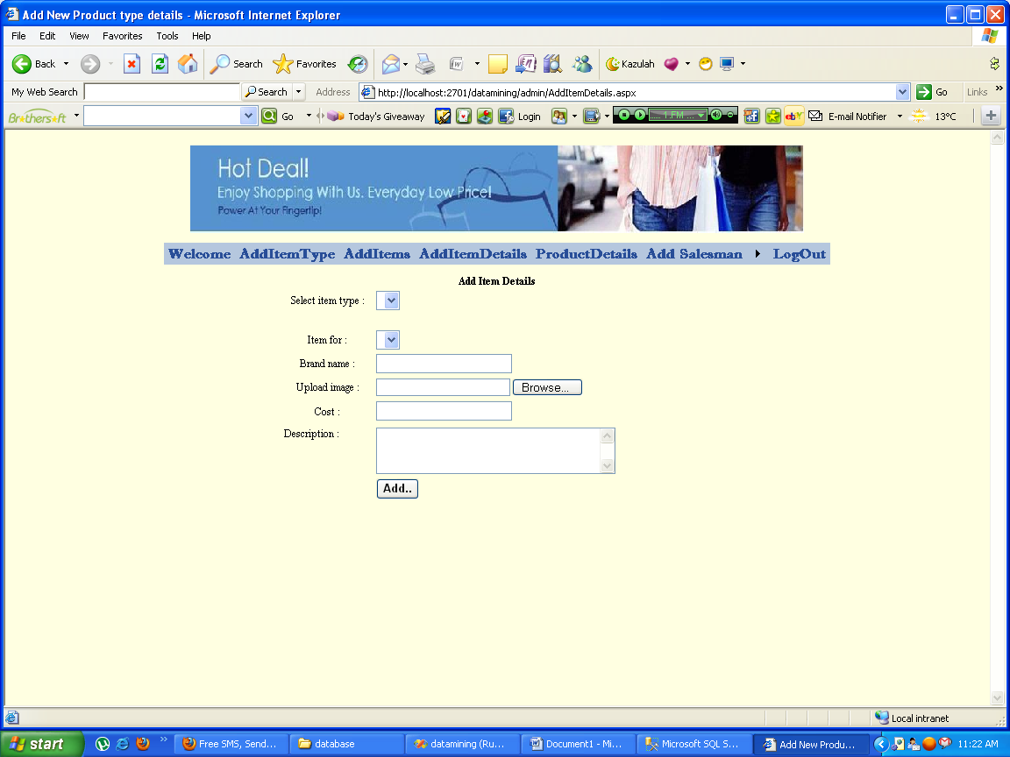
Pagename: add itemdetails
Fields: item type,item for,brand name,image,cost,desc
Process: can add product details
Table: tbl_itemsofproduct
Remarks: enter into fields
Error: no

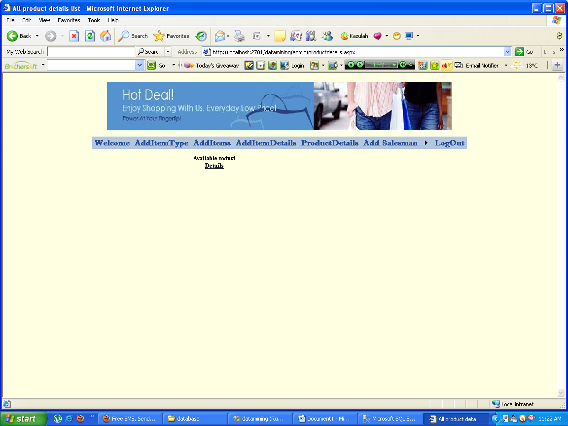
Pagename: product details
Fields: view
Process: can view product details
Table: tbl_itemsofproduct
Remarks: view
Error: no

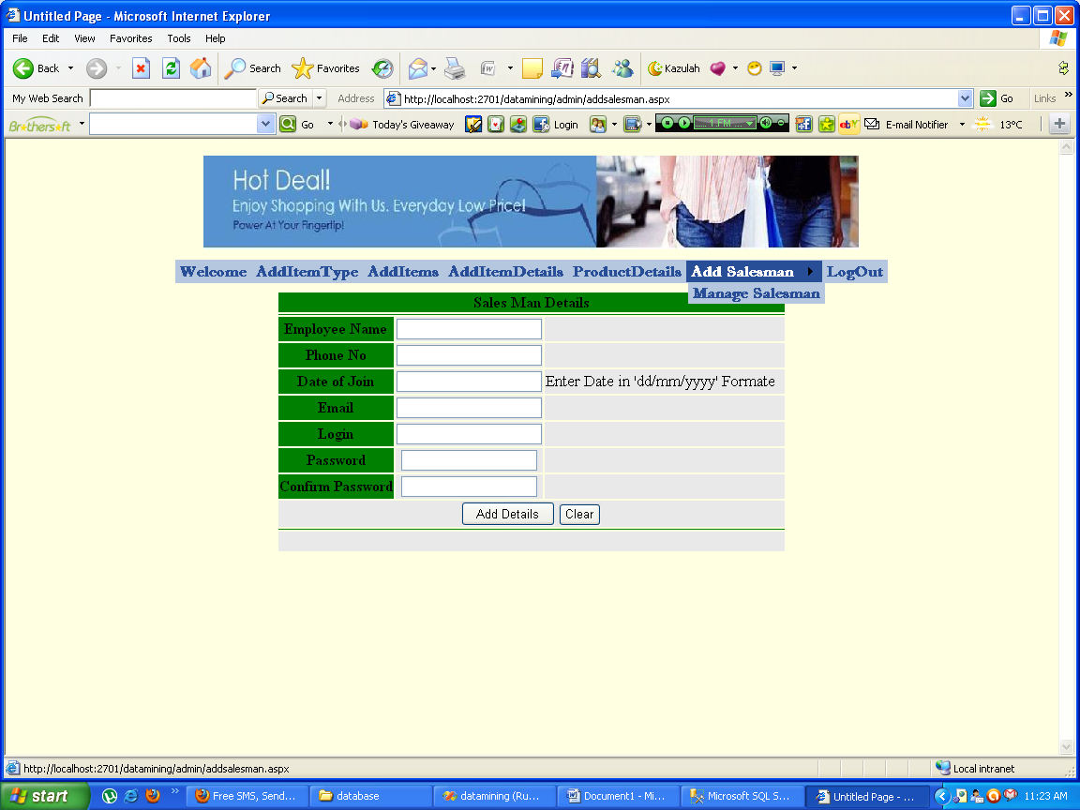
Pagename: add salesman
Fields: name,phone,doj,email,login,pwd,add details
Process: can add new emp
Table: tbl_newemp
Remarks: enter into fields
Error: no

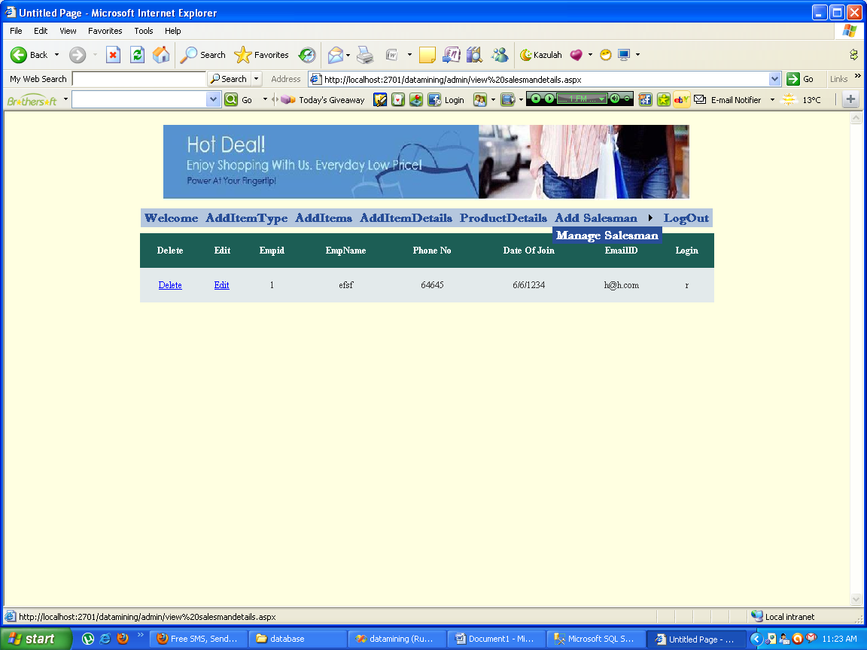
Pagename: manage salesman
Fields: gridview
Process: can manage emp
Table: tbl_newemp
Remarks: enter into fields
Error: no

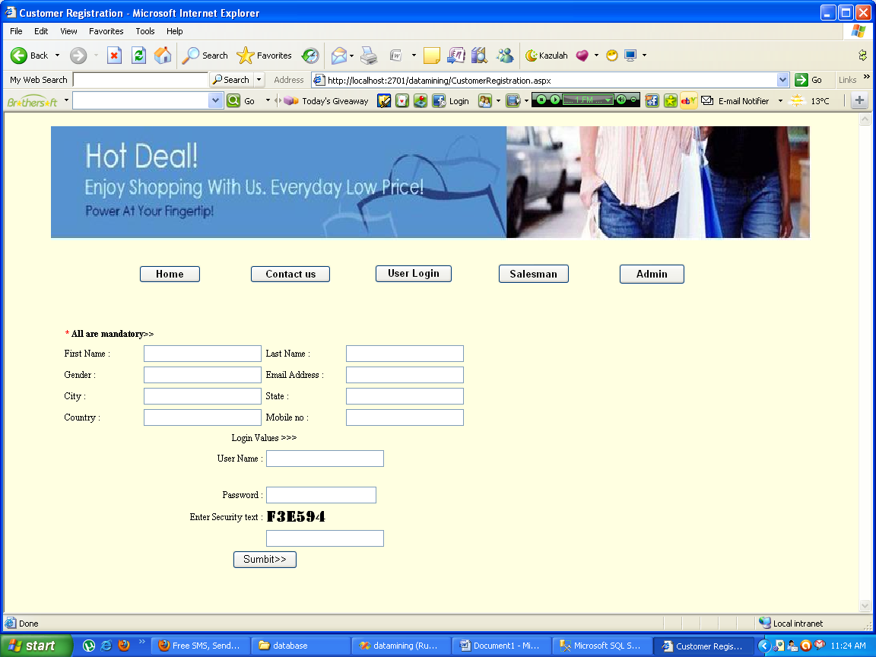
Pagename: user registration
Fields: name,gender,email,city,username,pwd
Process: can register new user
Table: tbl_login
Remarks: enter into fields
Error: no

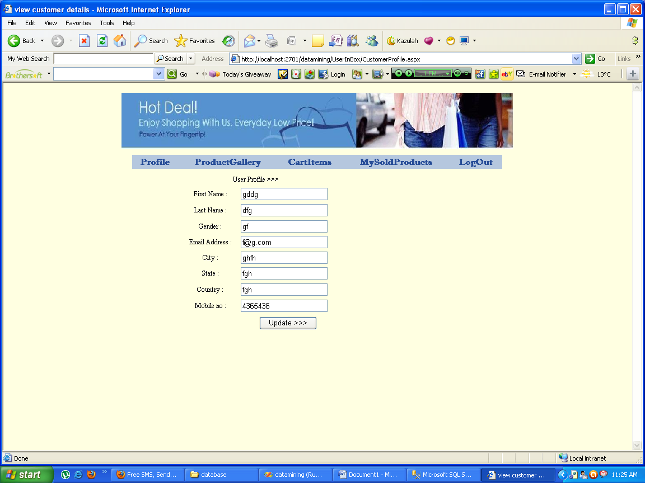
Pagename: update user profile
Fields: name,gender,email,city,mobile
Process: can update user
Table: tbl_login
Remarks: enter into fields
Error: no

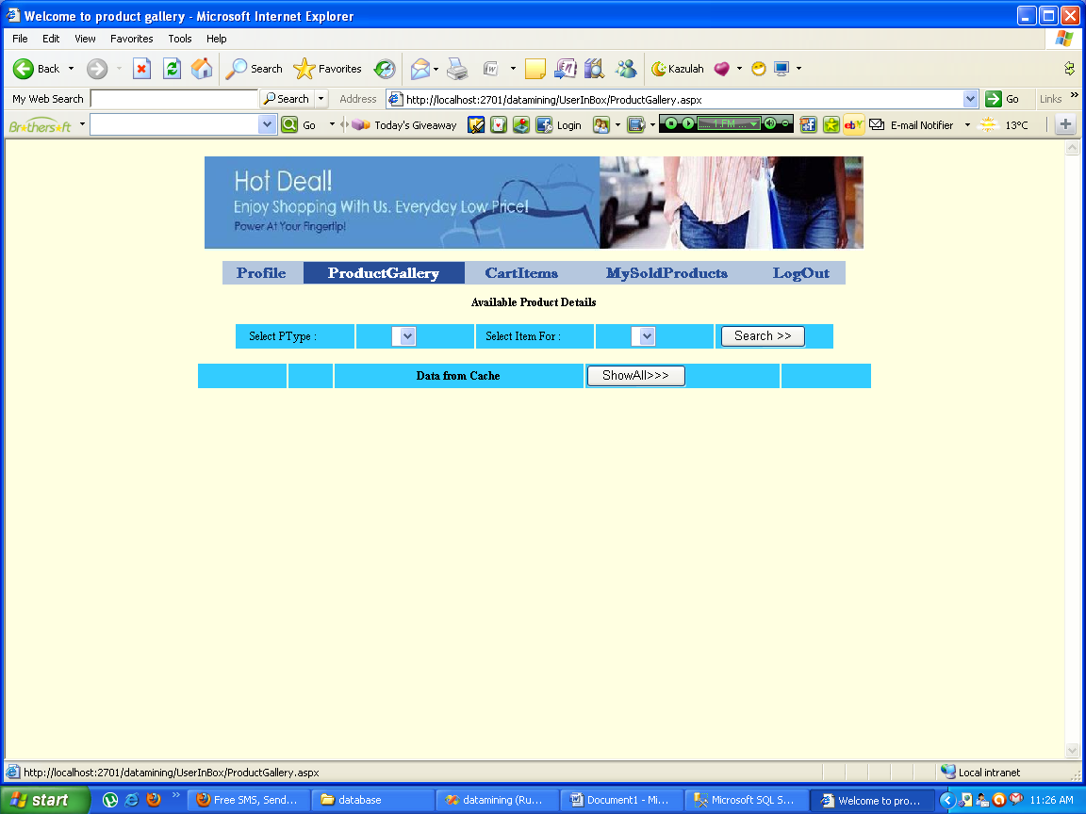
Pagename: product galary
Fields: select type,item
Process: can view product type
Table: tbl_productitemdetails
Remarks: select
Error: no

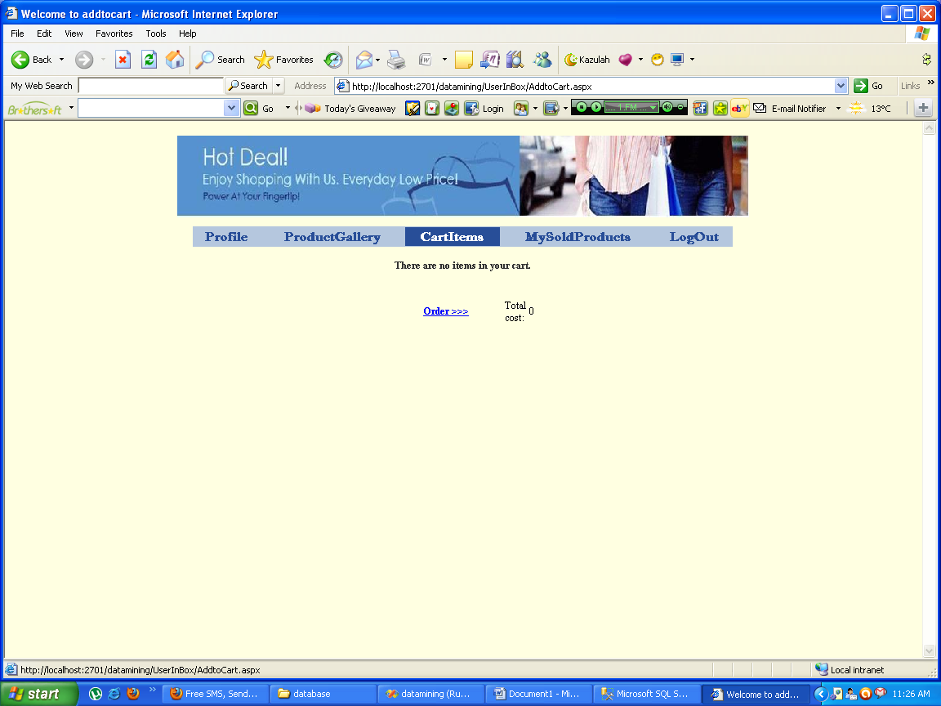
Pagename: cart items
Fields: order
Table: tbl_addtocart

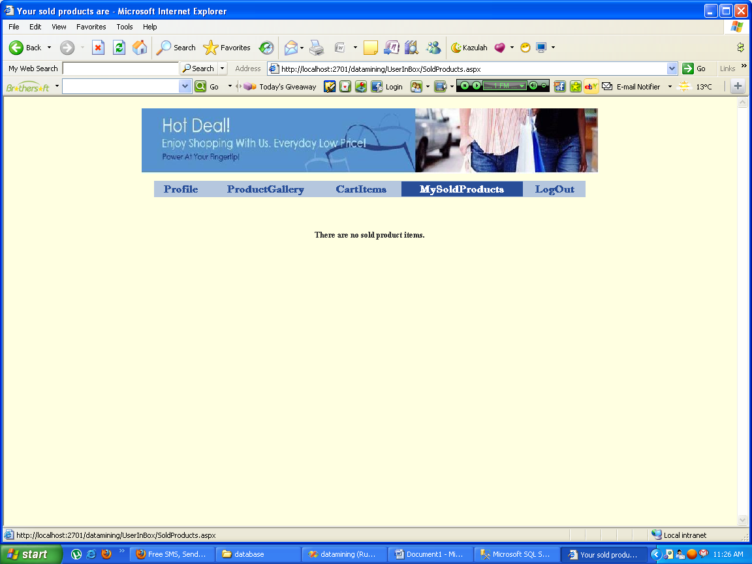
Pagename: my sold products
Fields: no
Process: can view sold products
Table: tbl_soldproducts
Error: no

